Industrial Technology Research Institute Internship

Name : Chiajui Lee

7/4/2025 MLCC X7R Dielectic Analysis 1
I. Introduction 1
II. Methodology 1
III. Conclusion 5
7/10/2025 Double Pulse Testing with X7R and Gate Drive Circuit 6
I. Introduction 6
II. Purpose 6
III. Test Environment 6
IV. Methodology 7
V. LTspice simulation 11
VI. Conclusion 13
7/14/2025 Characterization of LM74800EVM Gate Behavior 13
I. Introduction 13
II. Methodology 15
III. Conclusion 18
Appendix 19
7/4/2025 MLCC X7R Dielectic Analysis 19
7/14/2025 Characterization of LM74800EVM Gate Behavior 22

7/4/2025 MLCC X7R Dielectic Analysis
- Introduction
In this project, we conducted double pulse testing on a high-voltage switching circuit to evaluate its performance and reliability. During initial testing, we experienced repeated failures where X7R ceramic capacitors exploded when the applied voltage approached 800V. These failures occurred on two separate occasions and prompted further investigation into the underlying causes.
At the time, we considered two main possibilities: a potential issue with the PCB layout, or unexpected limitations of the capacitor itself. Since reference data for X7R capacitors at such high DC voltages was limited, we adopted a step-by-step testing method. Capacitors were soldered onto the PCB and tested row by row, allowing us to isolate failure points and better understand their behavior in our application.
Through this investigation, we discovered that the X7R dielectric exhibits significant performance degradation under high DC bias — a limitation we had not fully recognized at the start of the project. This finding ultimately influenced our decision to explore alternative capacitor types more suitable for high-voltage operation.
- Methodology
- Stable Operation During Row-by-Row Testing (column 1–5)
Capacitors were installed incrementally from column 1 to column 5 and tested at 800V by applying voltage directly to the PCB (capacitors only, without switching operation). After each step, both infrared imaging and visual inspection were performed to monitor any signs of abnormal thermal behavior or physical damage. No overheating or mechanical failure was observed during these tests.
Figure 1 shows the PCB with capacitors installed during the early stage of testing. Figure 2 presents an IR image captured during testing of column 2, demonstrating uniform thermal distribution. Figure 3 shows the PCB after installation of all five column, with no visible damage or discoloration. Figure 4 provides an IR image taken during the final test of column 5, again showing no abnormal temperature rise.
Additional IR and visual inspection images for each test from column 1 to column 5 are included in the Appendix (Figures A-1 to A-4).

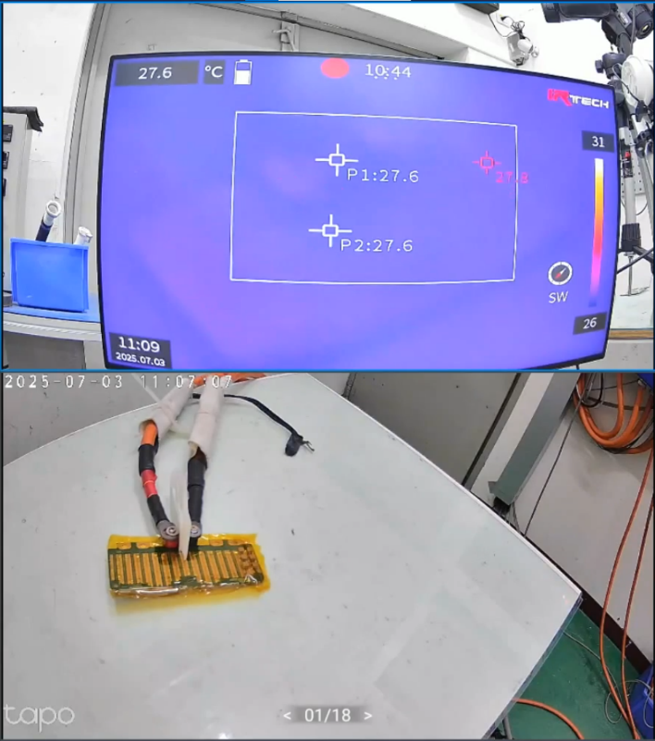
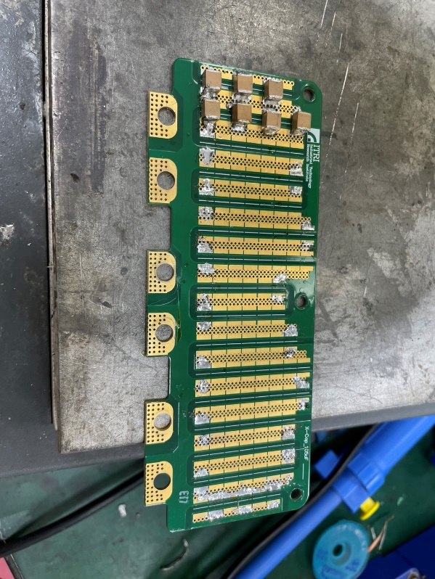

Figure 2 IR image for column 2

Figure 1 First stage testing

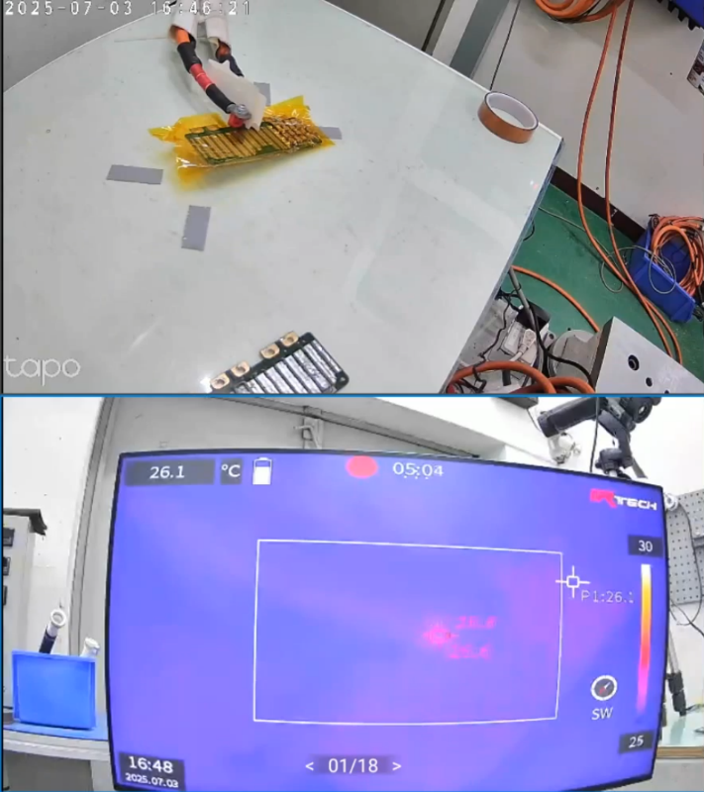
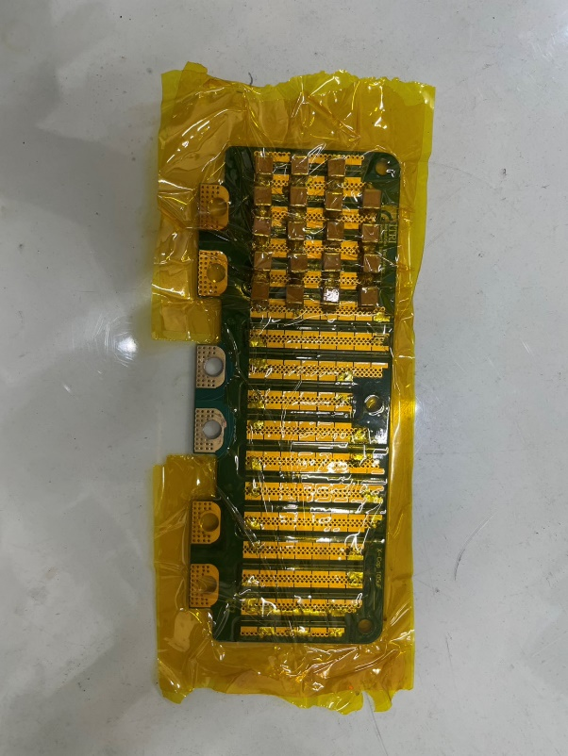

Figure 4 IR image for column 5

Figure 3 Installation of column 5

- Unexpected Behavior During Column 6 Installation and Investigation
When we installed capacitors in column 6, we observed unexpected behavior: as the voltage increased to 60 V, a small current began to flow—something that had not occurred during testing of the previous rows. This raised concerns about a possible short circuit, capacitor failure, or PCB layout issue. To investigate, we desoldered and measured the four capacitors from column 6 individually. One of them showed a slightly lower capacitance value (0.45 µF), compared to the expected value of around 0.48 µF. To determine whether the abnormality originated from the capacitor or the PCB, we re-soldered this specific capacitor onto the last column of the PCB and repeated the test. After re-testing, we determined that the current behavior was due to the startup characteristics of the power supply, not the capacitor or PCB. The earlier observation was therefore identified as a false alarm.
Figure 5 presents the power supply current behavior observed during the 60 V ramp-up. Figure 6 shows the reinstallation of the slightly out-of-spec capacitor on the last column for further verification.

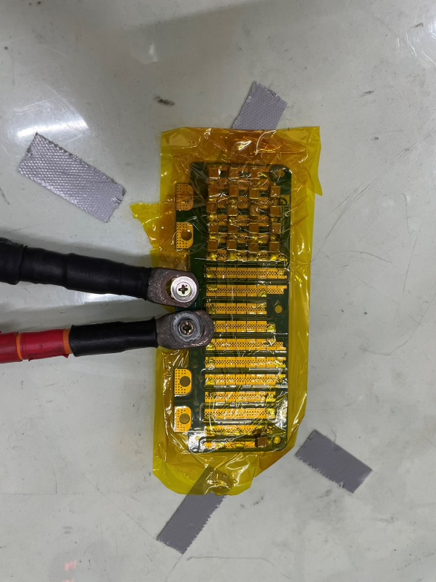

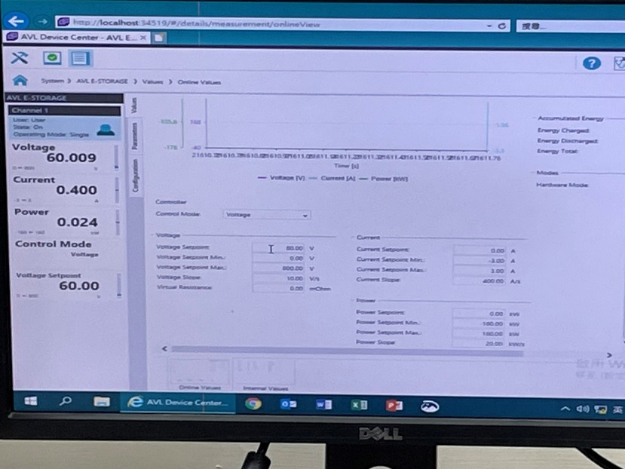

Figure 6 power supply current behavior

Figure 5 Installation of the last column

- Final Testing and Root Cause Identification
After completing the installation of column 6 and subsequently populating all remaining capacitor columns, we continued testing to verify the integrity of the PCB and the performance of the components under high voltage. Throughout these tests, no signs of physical damage, unexpected heating, or layout-related failures were observed.
Figure 7 shows the completed PCB with all capacitor columns installed. Figure 8 presents the corresponding IR image captured during the final high-voltage test, confirming stable thermal behavior across all capacitors.
Based on these results, we confirmed that the PCB layout and soldering were not responsible for the previously observed irregularities. Instead, the root cause was identified as a limitation of the X7R dielectric itself—specifically, its tendency to lose capacitance under high DC bias.
Additional IR and visual inspection images for each test from column 6 to the last column are included in the Appendix (Figures A-5 to A-14).
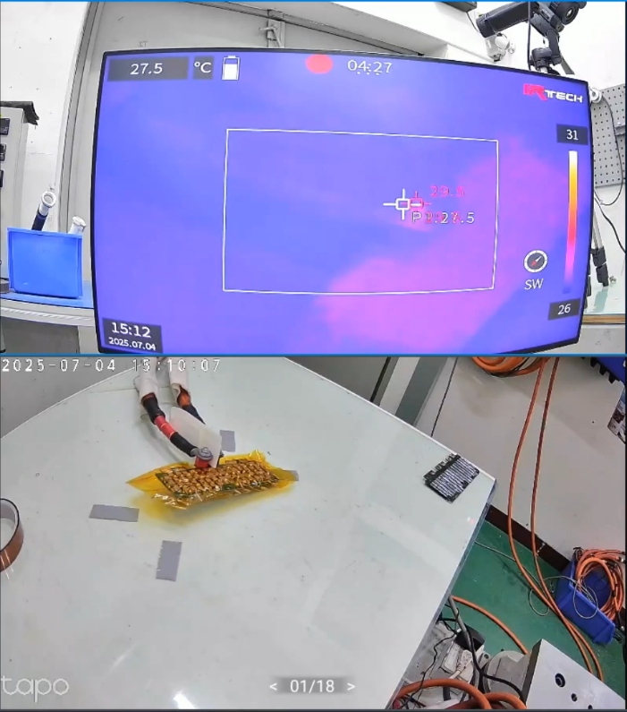
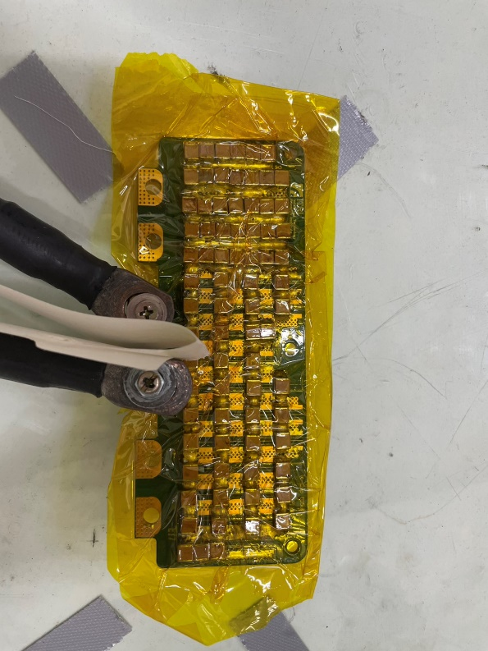

Figure 8 IR image for all the column

Figure 7 Installation of all the columns

- Conclusion
Through a series of step-by-step tests and infrared thermal observations, we determined that the unexpected behavior and capacitor failures observed during double pulse testing were not caused by the PCB layout or soldering quality. Instead, the root cause was identified as the inherent characteristics of the X7R dielectric. X7R capacitors are known to experience significant capacitance loss when subjected to high DC bias. In our case, the combination of this capacitance drop and the high-voltage spike present in the second pulse of the double pulse test caused the effective capacitance to fall below safe operating levels. As a result, the voltage stress exceeded the capacitor’s tolerance, leading to catastrophic failure at 800 V. This phenomenon had not been previously considered in our design. To address this issue, we are now exploring alternative capacitor types with more stable—or even inverse—bias behavior. One promising candidate is the PLZT capacitor, which exhibits the opposite trend of most ceramic dielectrics: its capacitance increases under high DC bias. This property makes it particularly suitable for high-voltage pulse applications like ours.
Figure 9 below shows the DC bias behavior comparison between typical X7R capacitors, PLZT capacitors, and Hiteca (SBFT) capacitors. While X7R shows a sharp drop in capacitance as voltage increases, PLZT exhibits a positive voltage coefficient, and Hiteca shows improved stability over a wide voltage range.
Figure 9. Capacitance vs. DC bias voltage comparison for X7R, PLZT, and Hiteca capacitors.
Adapted from Knowles Precision Devices blog: “FAQ: Does MLCC Capacitance Change with Voltage?”
Source: FAQ: Does MLCC Capacitance Change with Voltage?
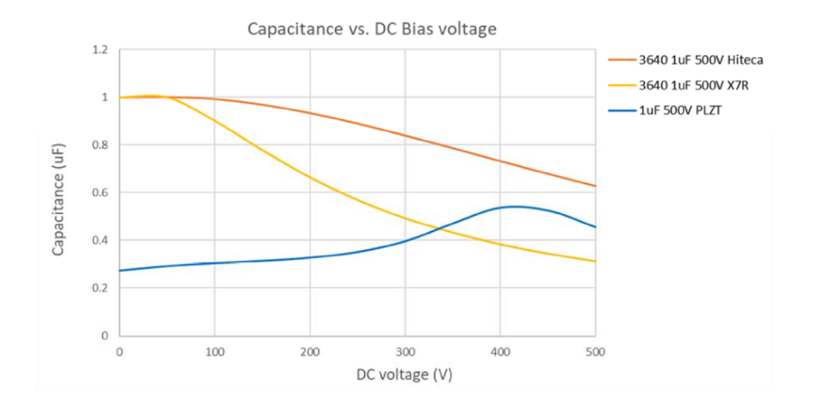

Figure 9 Capacitance versus DC bias voltage, measured at 1kHz

7/10/2025 Double Pulse Testing with X7R and Gate Drive Circuit
- Introduction
After completing component-level and capacitor-only testing, we proceeded to validate the circuit using the full hardware setup. This comprehensive configuration included the power supply, gate drive circuitry, inductors, and capacitor bank to simulate actual switching behavior during double pulse testing.
The setup was composed of the following major components:
- Power Supply: A high-voltage programmable DC source used to charge the capacitor bank up to 600 V.
- Gate Driver Board: A custom-designed driver circuit responsible for controlling the switching device (e.g., SiC MOSFET), ensuring precise pulse timing and isolation.
- Input and Output Inductors: A 200 µH inductor on the input side and a 225 µH inductor on the load side were used to emulate the energy transfer and observe the switching characteristics under inductive load.
- Capacitor Bank: A total of 37 µF composed of X7R ceramic capacitors, used as the DC link for energy storage during the pulse events.
- Purpose
Double pulse testing is a widely used method to evaluate the switching behavior of power semiconductor devices such as SiC MOSFETs. This test allows us to extract key performance parameters including:
- Transient response of the device
- Switching losses (turn-on and turn-off energy)
- Voltage overshoot across the drain-source during switching
- Switching speed (dv/dt) and its impact on EMI
- Dead time behavior and its influence on safe operation
This test is critical in verifying whether the gate drive, layout, and passive components can support the fast-switching nature of SiC devices.
- Test Environment
All experiments were conducted in a controlled laboratory environment at ITRI, using a grounded anti-static workbench. Ambient temperature was approximately 25 °C. High-voltage tests were performed with proper insulation and safety protocols in place.
Waveform monitoring was performed using a Tektronix MSO46B mixed signal oscilloscope, which enabled high-resolution capture of voltage and current transients. The gate pulse timing and signal control were managed by a UTG2062X function/arbitrary waveform generator, which provided accurate double pulse sequences for testing. All test instruments were calibrated prior to use to ensure measurement consistency.
Figure 10 shows an overview of the experimental environment and equipment layout. Figure 11 provides a close-up view of the full circuit under test, including the capacitor bank evaluated in the previous chapter, now integrated into the full switching setup.
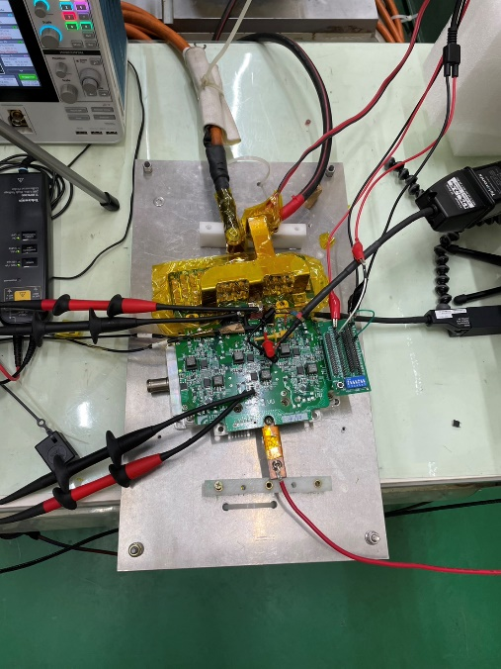
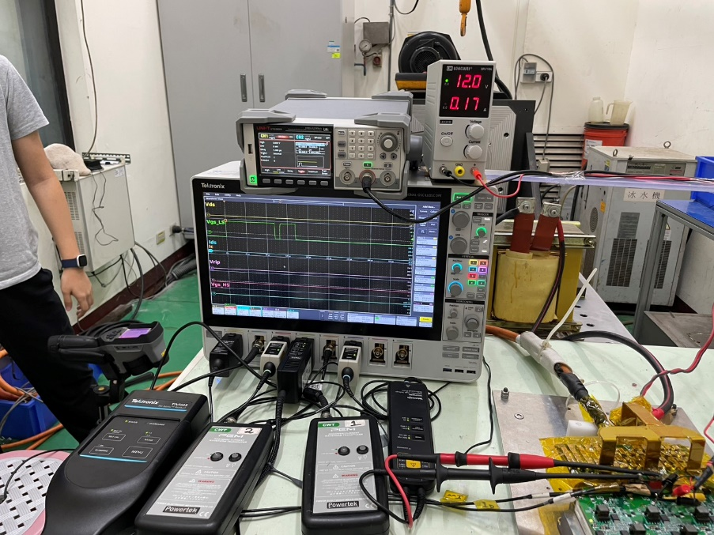

Figure 11 Close-up look of the circuit

Figure 10 Experimental Environment

- Methodology
- Test 1 – Double Pulse Timing: Width 40 µs, Gap 20 µs, Second Width 15 µs
The purpose of this test was to evaluate the switching behavior of the SiC MOSFET under various input voltages and observe how V_{ds} and I_{ds} respond to voltage scaling. The test was performed at three voltage levels: 170 V, 400 V, and 450 V, while the rest of the setup remained constant.
Figure 12 shows the double pulse waveform measured at 170 V, Figure 13 shows the waveform at 400 V, and Figure 14 shows the waveform at 450 V.
Table 1 summarizes the test results, highlighting the maximum drain-source voltage and peak capacitor’s current observed during the second pulse at each voltage level.

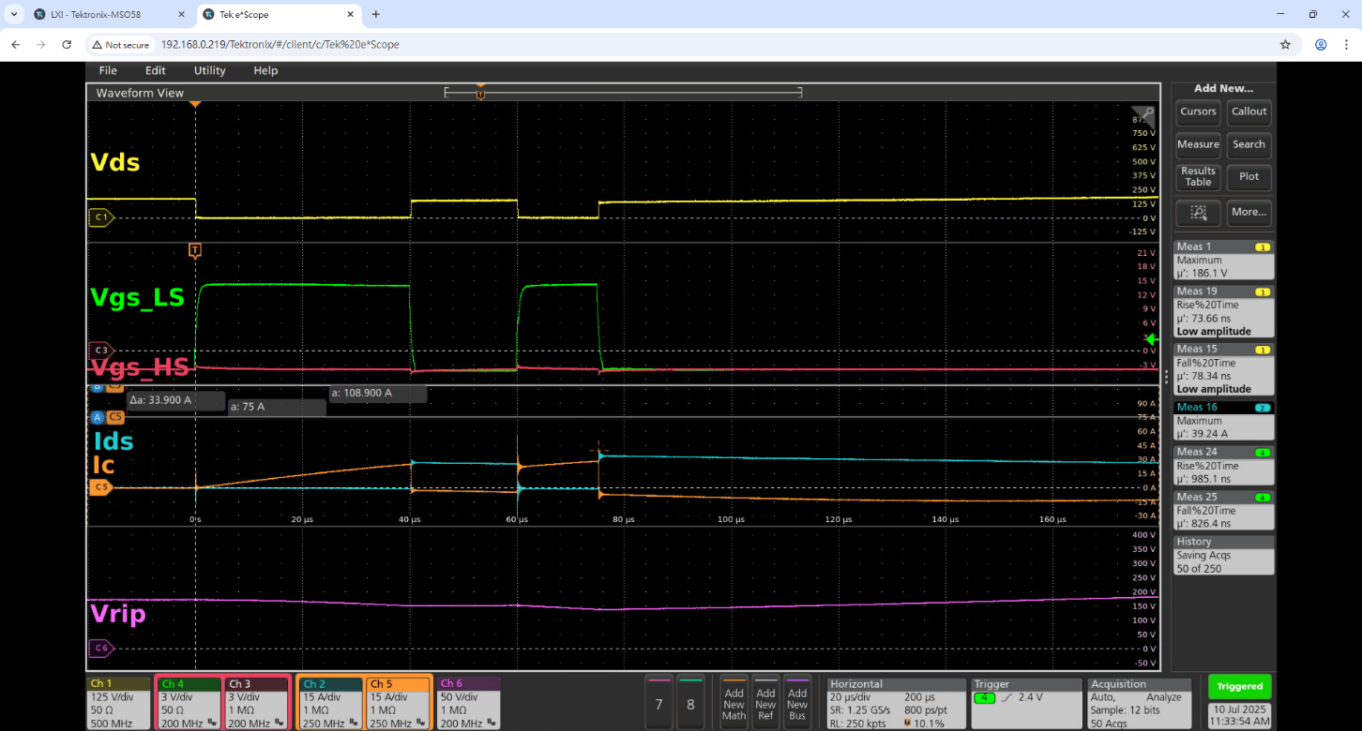

Figure 12 Waveform measured at 170V input

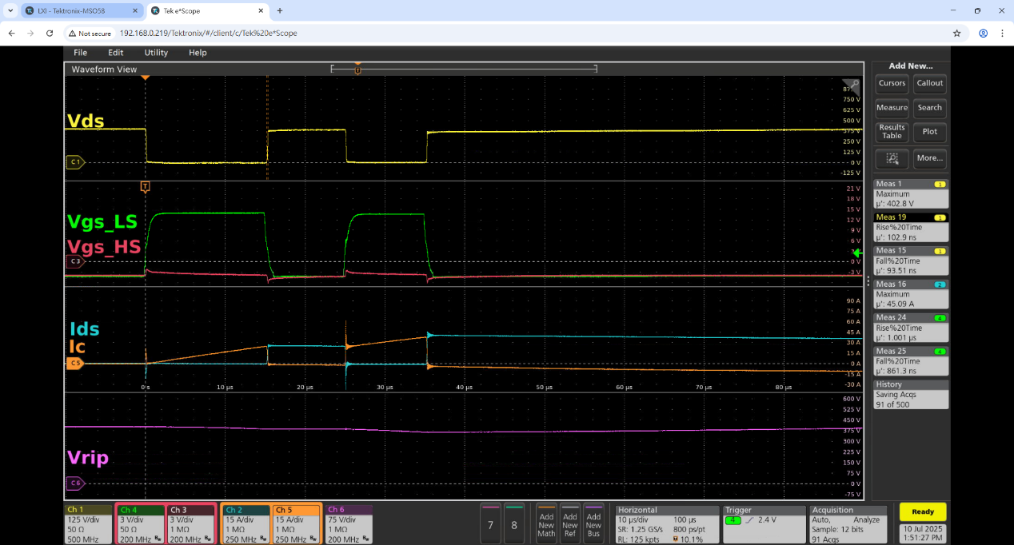

Figure 13 Waveform measured at 400V input

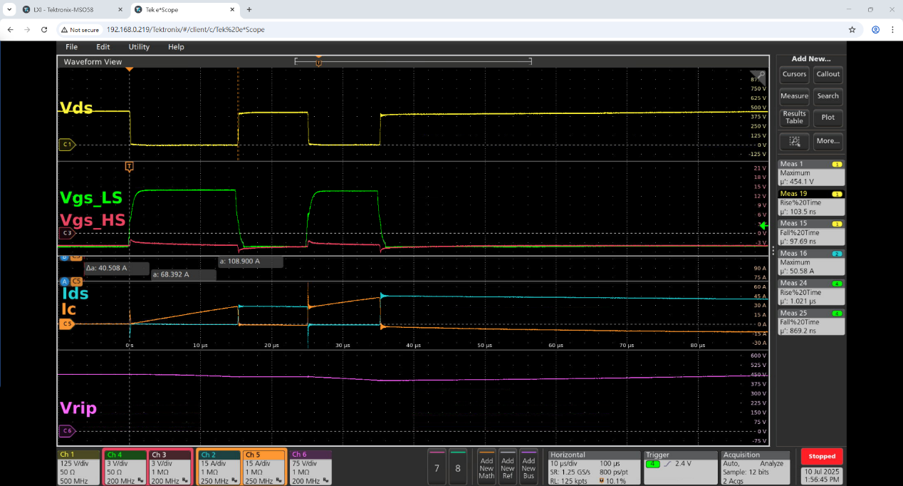

Figure 14 Waveform measured at 450V input

Input Voltage | Maximum V_{ds} | Maximum I_{C}
170V | 186.1V | 56.3A
400V | 402.8V | 60.5A
450V | 454.1V | 68.4A

Table 1 Test results for Double Pulse Timing: Width 40 µs, Gap 20 µs, Second Width 15 µs

- Test 2 – Double Pulse Timing: Width 10 µs, Gap 5 µs, Second Width 7 µs
In this second test, we used a shorter and faster double pulse pattern to evaluate the SiC MOSFET’s behavior under more dynamic switching conditions. The updated timing parameters were:
- First Pulse Width: 10 µs
- Gap (Off Time): 5 µs
- Second Pulse Width: 7 µs
This test condition more closely resembles high-frequency switching seen in practical converter designs, and it was used to further evaluate:
- The device's transient switching performance
- dv/dt and di/dt effects
- Voltage overshoot
- Any thermal buildup under faster switching
This time voltages—200 V, 450 V, and 600 V—were applied.
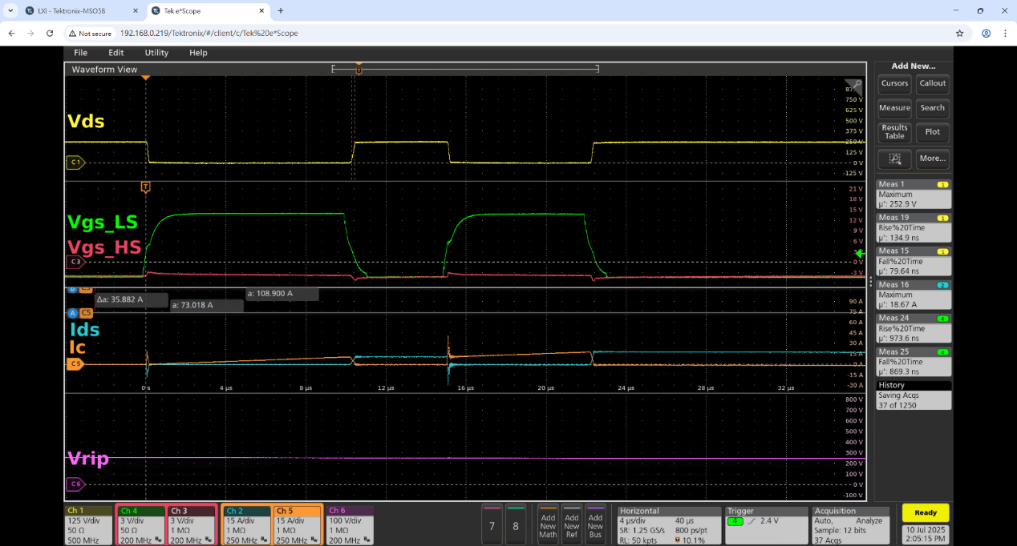
Figure 15 to Figure 17 show the measured waveforms for 200 V, 450 V, and 600 V, respectively. Table 2 summarizes the observed peak drain-source voltage and the capacitor’s current for each voltage level under the new pulse configuration.

Figure 15 Waveform measured at 200V input

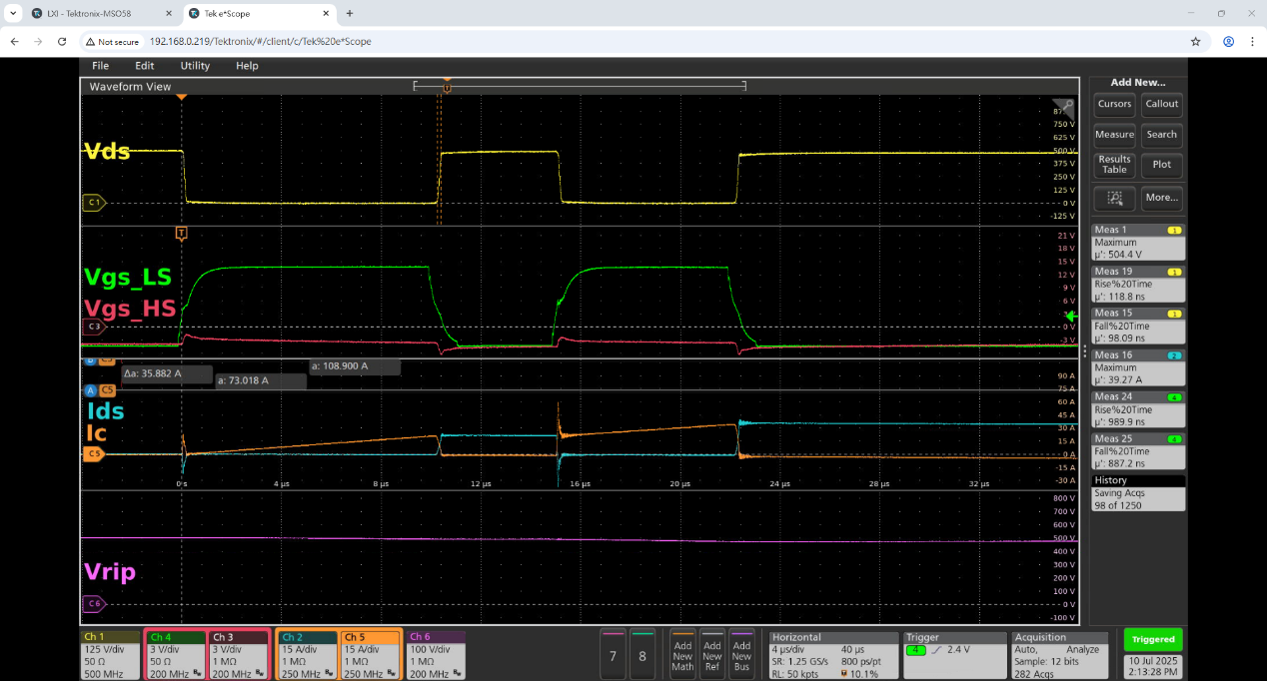

Figure 16 Waveform measured at 450V input

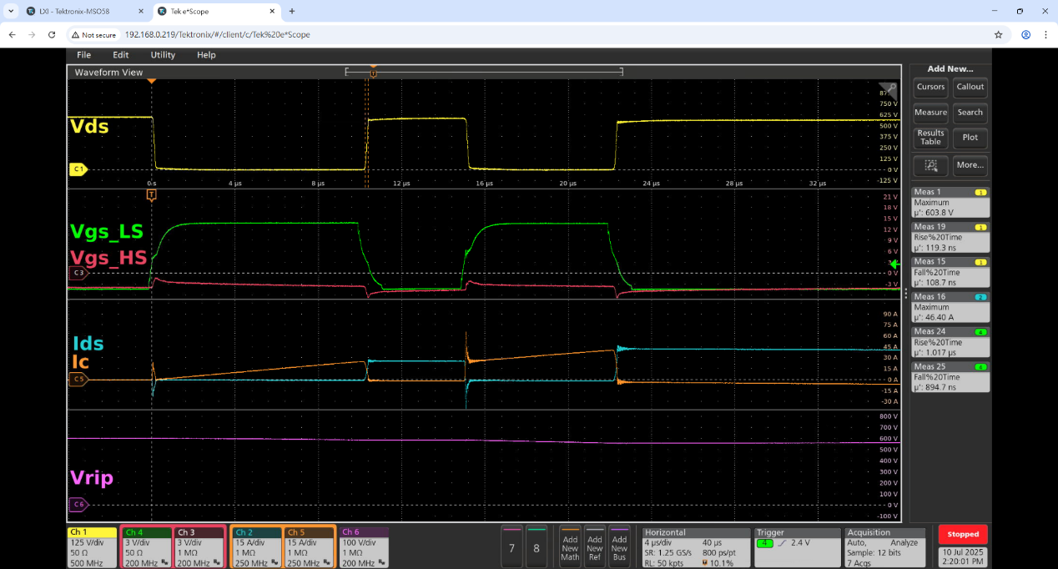

Figure 17 Waveform measured at 600V input

Input Voltage | Maximum V_{ds} | Maximum I_{C}
200V | 250.2V | 43.8A
450V | 429.5V | 59.8A
600V | 603.8V | 64.5A

Table 2 Test results for Double Pulse Timing: Width 10 µs, Gap 5 µs, Second Width 7 µs

- LTspice simulation
To deepen our understanding of the double pulse test circuit and the underlying switching behavior, we performed simulations using LTspice, as recommended by our mentor. This simulation exercise served both as a learning tool and as a way to cross-check experimental behavior in a controlled environment.
The simulation model was developed based on Wolfspeed’s double pulse test application note, and we used Wolfspeed’s official SiC MOSFET SPICE model to ensure accurate representation of the switching characteristics.
Figure 18 shows the LTspice schematic used for simulation. Figure 19 presents the simulated waveforms, where switching transients such as voltage overshoot and current spikes can be observed. These results provided useful insights into how inductance and capacitor behavior influence stress on the SiC device during high-speed switching.
Additionally, Figure 20 confirms that the circuit is consistently operating under hard-switching conditions. The overlap between the drain-source voltage (V_{ds}) and drain current (I_{d}) forms a distinct triangular area, indicating energy loss during switching transitions. This triangle represents the switching loss, which is a key concern in high-efficiency converter design.
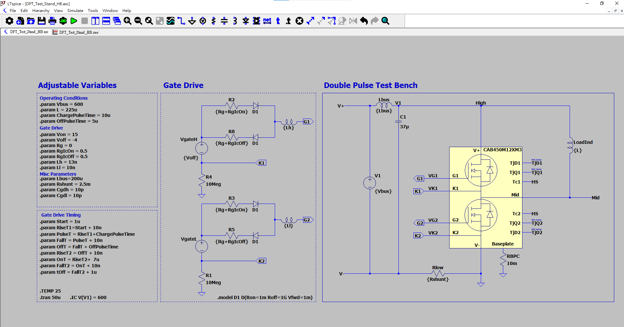

Figure 18 LTspice simulation

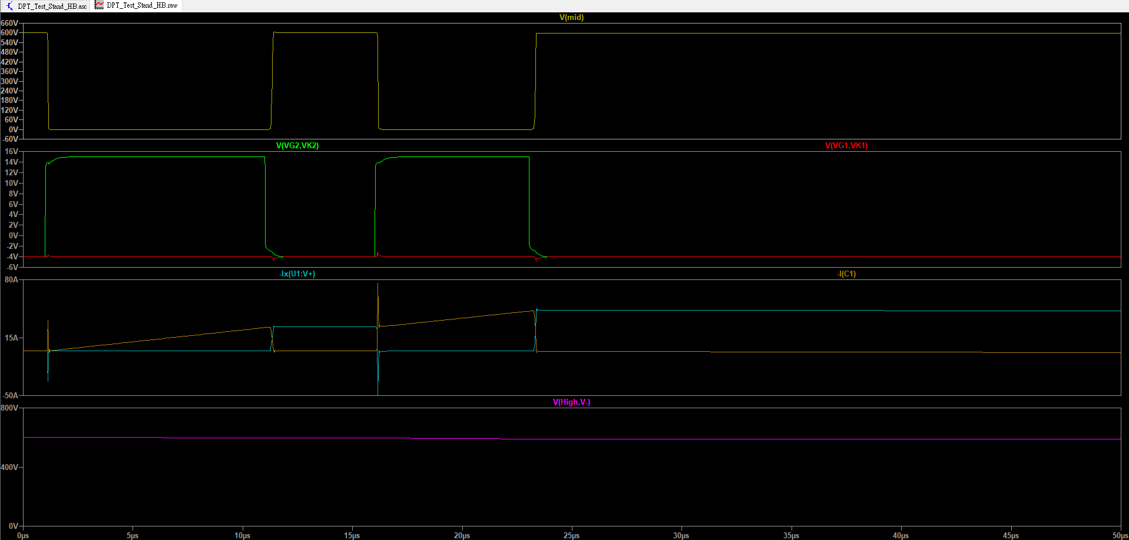

Figure 19 Simulated waveform

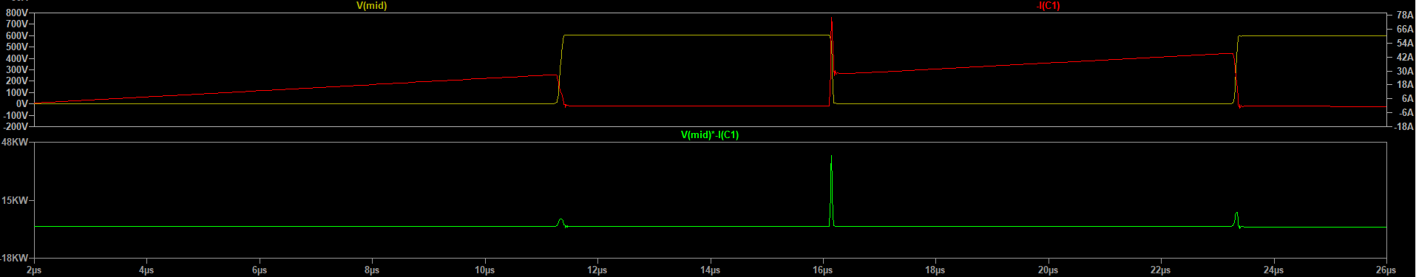

Figure 19 Switching Loss

- Conclusion
The double pulse test was conducted to evaluate the switching behavior of a SiC MOSFET under various operating voltages and to observe critical factors such as switching loss, voltage overshoot, and transient current response. Using a pulse sequence of 40 µs / 20 µs / 15 µs, we tested the circuit at 170 V, 400 V, and 450 V.
The results showed that as the input voltage increased, both V_{ds} overshoot and I_{d} peak current also increased, highlighting the need for careful voltage margin and thermal design in high-voltage switching applications.
The test also provided insight into the hard-switching nature of the setup, with visible overlap between voltage and current waveforms, indicating switching losses. These results matched expectations for SiC devices operating without soft-switching techniques, and they establish a baseline for further optimization of gate drive timing, dead time, and snubber design.

7/14/2025 Characterization of LM74800EVM Gate Behavior
- Introduction
The LM74800-Q1 is an ideal diode controller with integrated reverse polarity protection and fast gate control, designed to drive two external N-channel MOSFETs. It is commonly used in automotive and industrial power systems for efficient reverse current blocking and controlled startup behavior.
In our project, the LM74800 is located on the 12 V output side of the DC-DC converter board. Before analyzing its behavior in the full system, we performed an independent evaluation using the LM74800EVM, Texas Instruments’ official evaluation board.
The purpose of this experiment was to observe the key internal and gate-related signals of the LM74800 under normal operating conditions. Specifically, we measured:
- HGATE – Gate control signal for the high-side MOSFET
- DGATE – Gate control signal for the ideal diode MOSFET
- Charge pump voltage (V_{CP}– Measured across the capacitor connected between the CAP and VS pins, used to supply the gate drive for HGATE
- V_{D}– The voltage measured at the midpoint between the two external MOSFETs, representing the controlled output voltage
To examine whether the abnormal behavior observed in our main DC-DC board was due to the MOSFET used, we disconnected Q1 (the MOSFET originally provided on the TI EVM) and replaced it with our own MOSFETs, Q2 and Q3. This change allowed us to investigate how different MOSFETs interact with the LM74800 controller.
Figure 20 shows the original schematic from the TI LM74800EVM User Guide [Texas Instruments]. The original Q1 has been removed, and our custom test circuit using Q2 and Q3 is marked. This configuration enabled targeted observation of gate and charge pump behavior with our selected components.
Vgs Q1A
Vd
Vgs Q1B
C3 charge pump
Vout
2、3接一起
1、2接一起
Figure 21 presents a photo of the actual PCB board, with annotations marking the testing points used for probing HGATE, DGATE, VD, and the charge pump voltage (VCP).
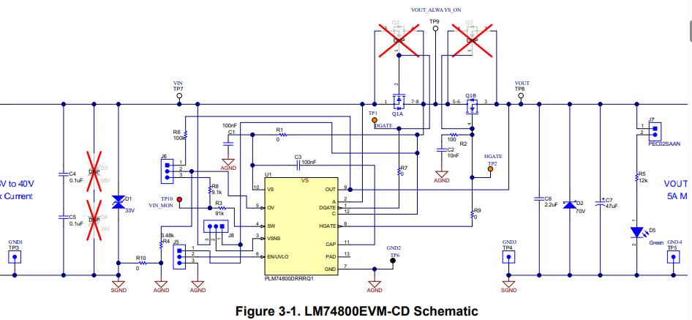
Vout
Vgs Q1B
Vgs Q1A
Vin
Figure 20 Circuit Schematic

Vd
C3 charge pump
1、2 are connected
2、3 are connected

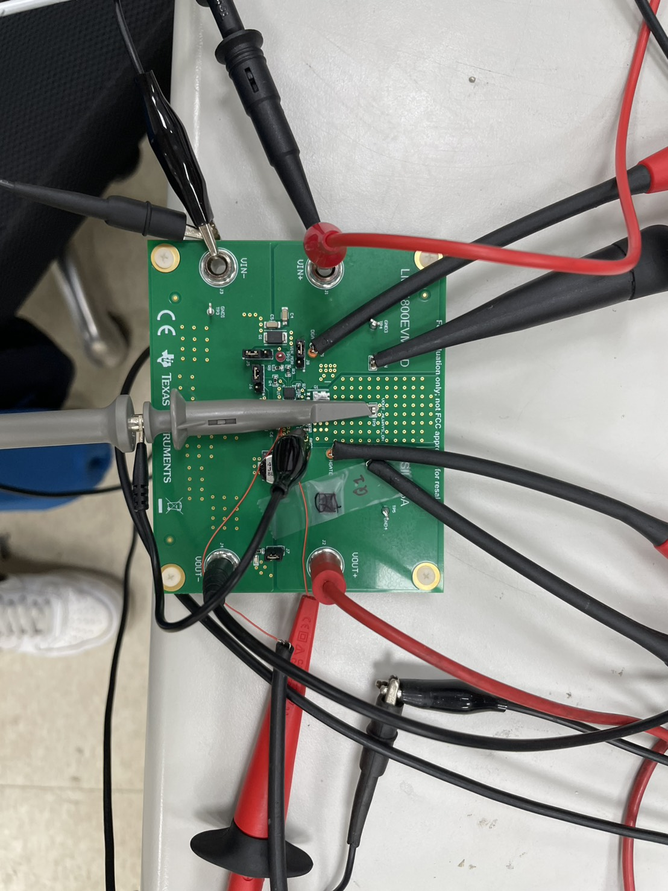

Vs A
Vs B
Vin+&Vin-
Vout(Load)

Vdrain
C3 Charge pump

Figure 21 Circuit connection

- Methodology
To evaluate the LM74800 under different conditions, we began testing under no-load and progressively applied discrete cement resistors until the output current reached approximately 0.1 A. Tests were conducted at two voltage levels: 7 V and 12 V. Specifically, we observed LM74800 gate signals and internal voltages including HGATE, DGATE, VD (the midpoint between external MOSFETs), and the charge pump voltage (measured across the capacitor between CAP and VS).
Note: Due to a misconfiguration when measuring VD with the carbon resistor, the displayed values must be multiplied by 10 to reflect the actual voltage.
Table 3 summarizes the test conditions and indicates whether the DGATE signal on Q1A exhibits a triangular waveform, which may be related to switching behavior or gate instability under certain load levels. Figure 22 shows the waveform at 7 V with no load, while Figure 23 captures the response at 7 V with 0.11 A (66 Ω). Similarly, Figure 24 shows the behavior at 12 V with no load, and Figure 25 with 0.14 A (91 Ω).
Additional screenshots and details of signal behavior across various loading conditions can be found in the Appendix (Figures A-15 to A-20).
7V | Whether the DGATE signal on Q1A exhibits a triangular waveform | 12V | whether the DGATE signal on Q1A exhibits a triangular waveform
No load | Y | No load | Y
0.11A/66Ω | N | 0.14A/91Ω | N
0.22A/32.5Ω | N | 0.25A/50Ω | N
0.31A/22.2Ω | N | 0.37A/32Ω | N
0.57A/12.2Ω | N | 0.98A/12.2Ω | N
0.02A/910Ω | Y | 0.02A/910Ω | N
0.02A/885Ω | Y | 0.02A/885Ω | N
Table 3 Test conditions
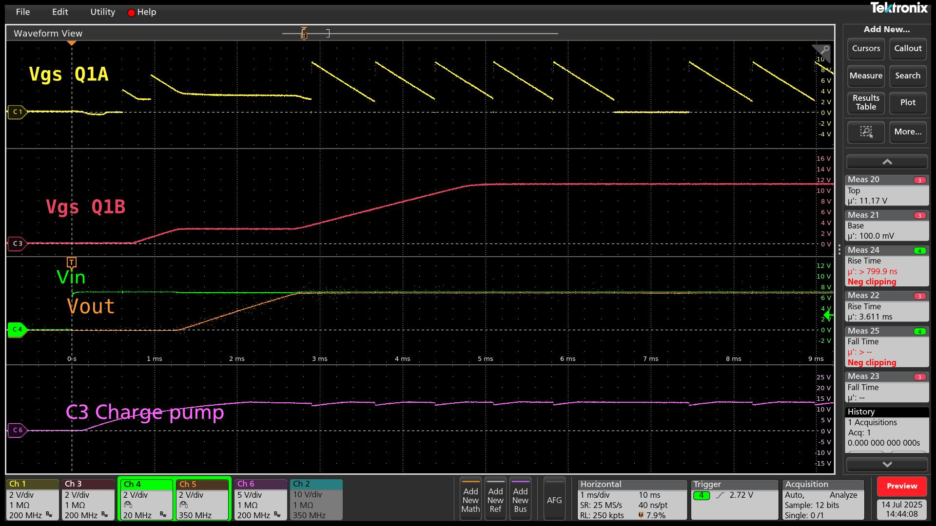

Figure 22 Waveform at 7 V, no load

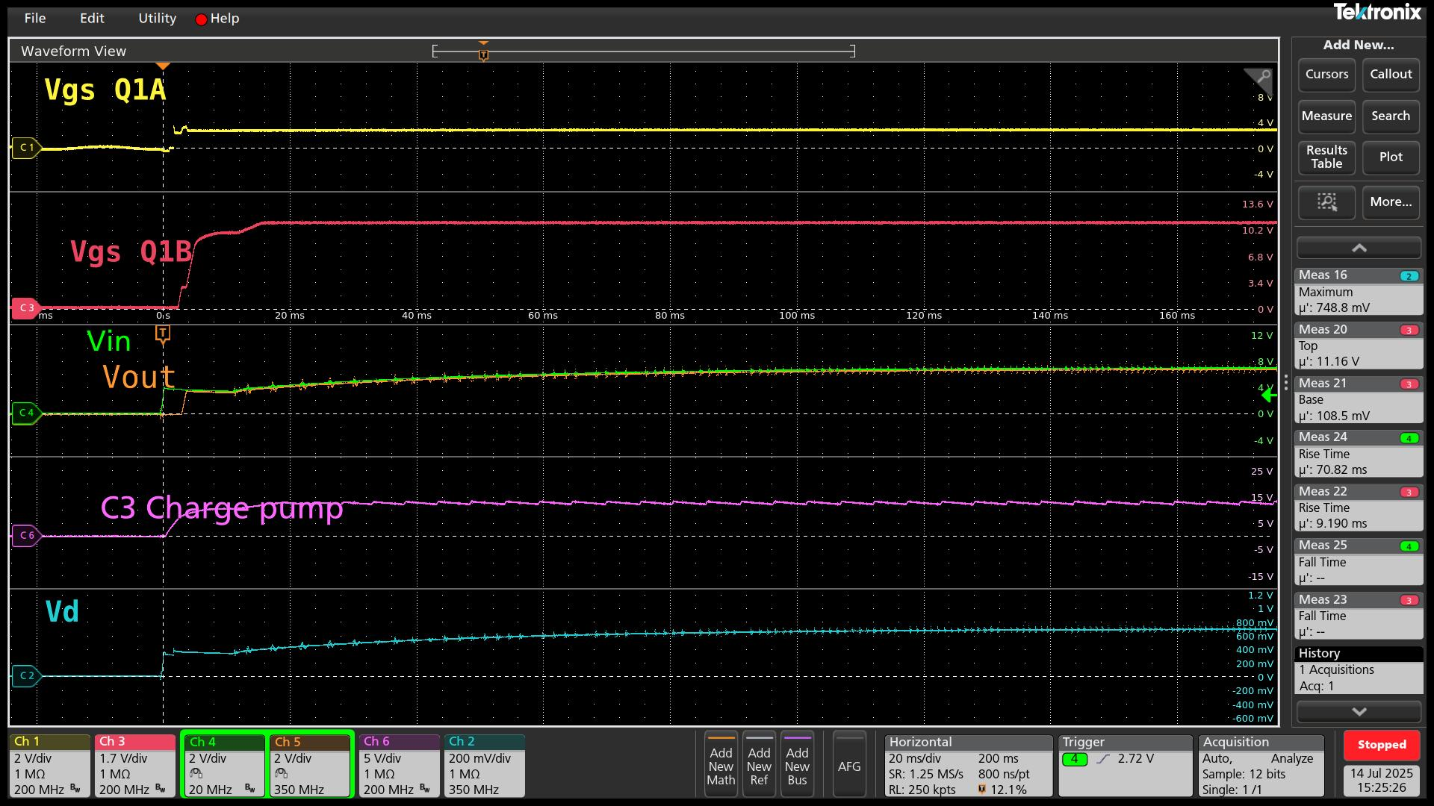

Figure 22 Waveform at 7 V, 0.11A (66Ω load)

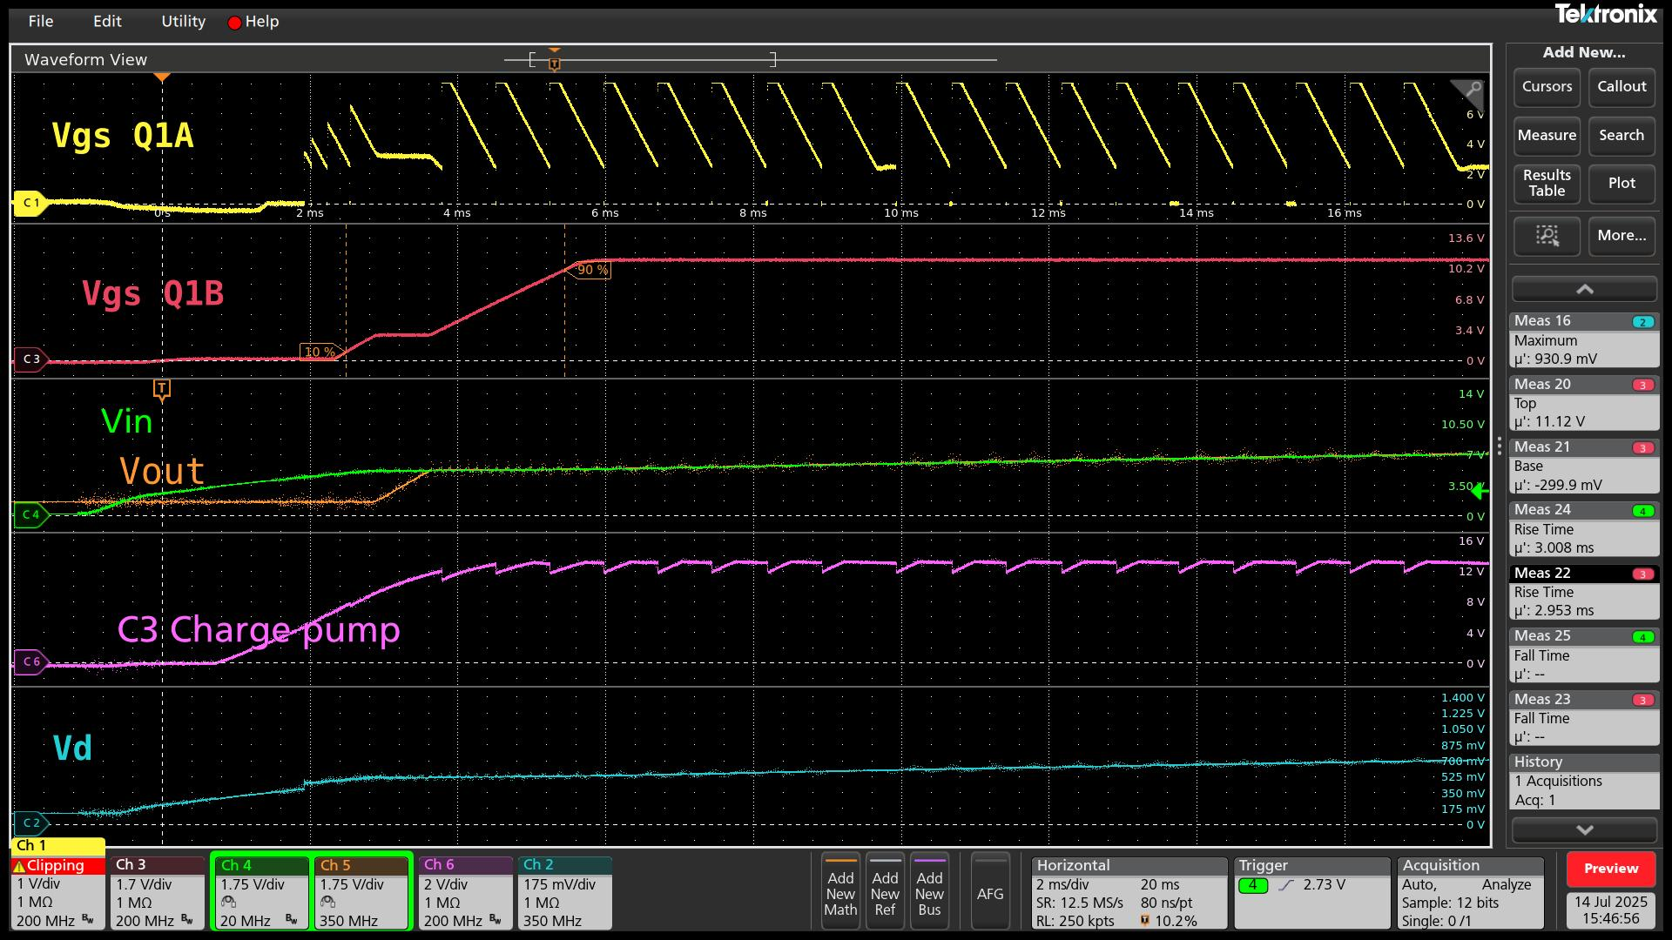

Figure 23 Waveform at 12 V, no load

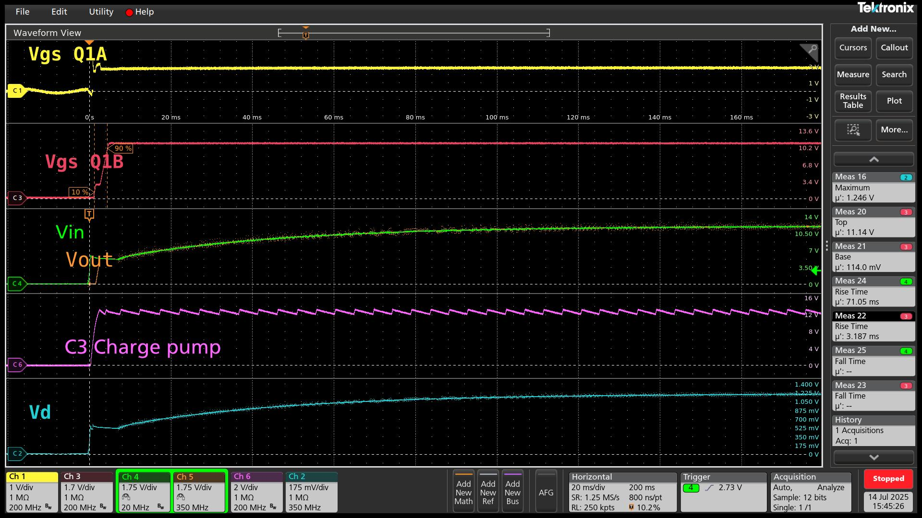

Figure 24 Waveform at 12 V, 0.14A (91Ω load)

- Conclusion
When using the Texas Instruments LM74800EVM, we observed that the DGATE signal (Q1A) exhibits noticeable oscillation under no-load conditions. In contrast, applying a load—such as a cement resistor—stabilizes the waveform and eliminates the oscillation. This behavior is not explicitly documented in either the EVM user guide or the LM74800 datasheet. We hypothesize that the lack of load affects the stability of the internal control loop, possibly due to high open-loop gain and insufficient damping, leading to oscillations at high frequency. Additionally, we found that the power supply and potential noise on the EN (Enable) pin may also influence this instability.
From a related discussion on TI’s E2E forum, it is confirmed that the LM74800-Q1 uses a linear gate regulation scheme to maintain a constant forward voltage (approximately 10.5 mV) across the MOSFET. This regulation dynamically adjusts the gate drive based on load current—raising the gate voltage as current increases, and pulling it low when current is near zero to prevent reverse current flow. This mechanism explains the oscillation of DGATE at no load, as the gate is actively driven low to maintain regulation.
Reference: TI E2E Forum Discussion on DGATE Oscillation
For deeper insight into this behavior, readers are encouraged to consult Section 6.1, “Linear Regulation Control vs. Hysteretic ON/OFF Control,” in TI’s Basics of Ideal Diodes application note.

Appendix

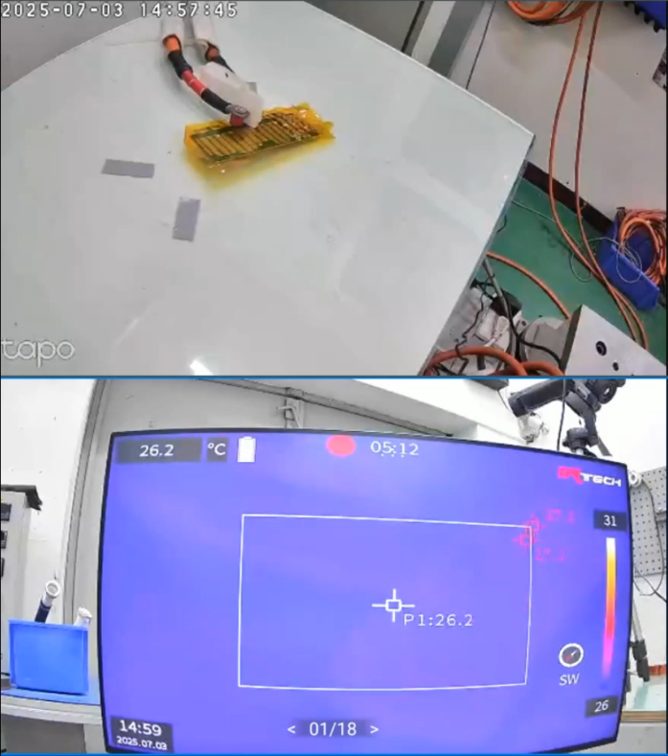
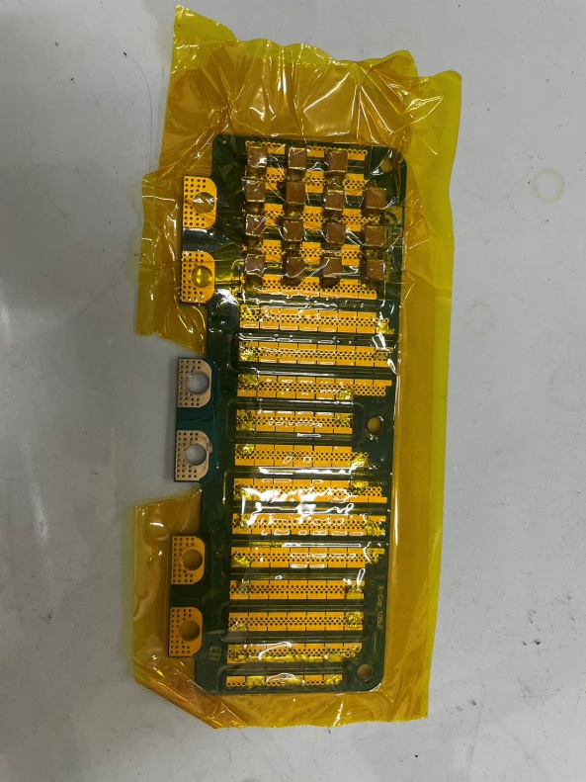
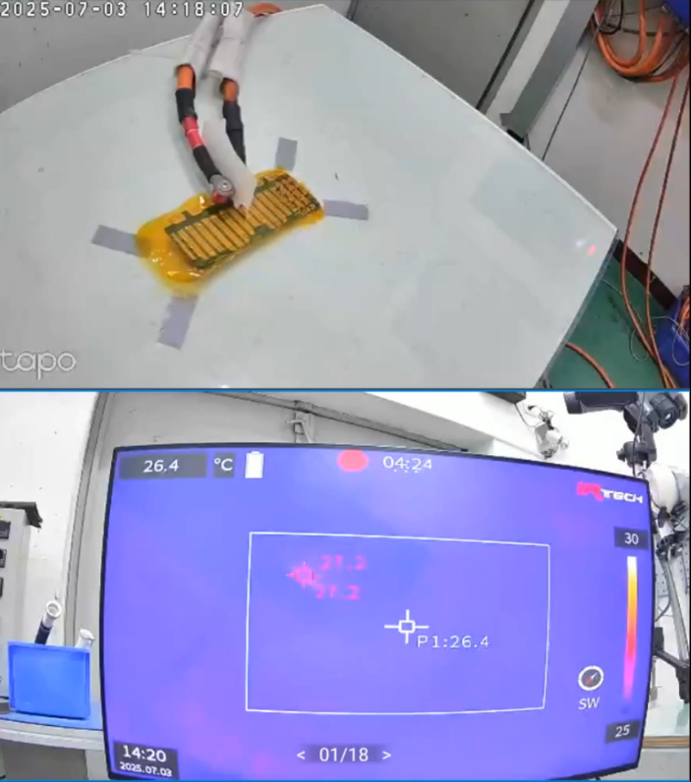
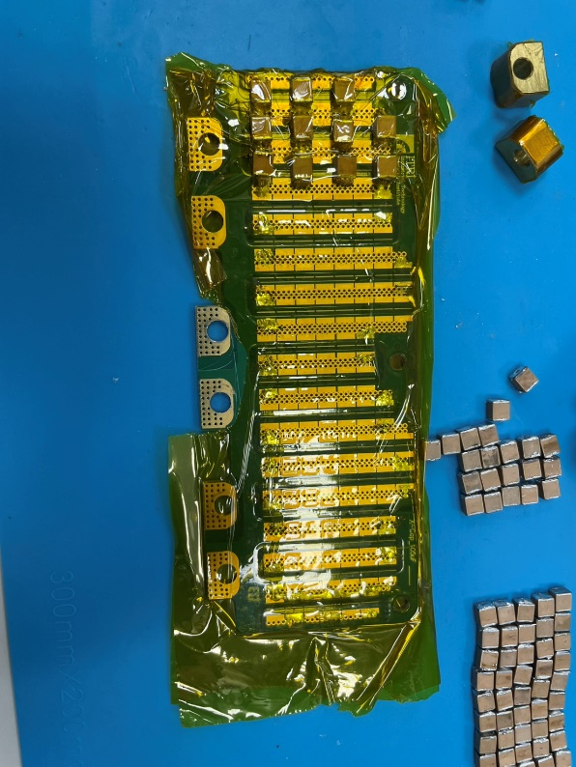
7/4/2025 MLCC X7R Dielectic Analysis
Figure A-4 IR image for column 4

Figure A-3 Installation of column 4

Figure A-2 IR image for column 3

Figure A-1 Installation of column 3

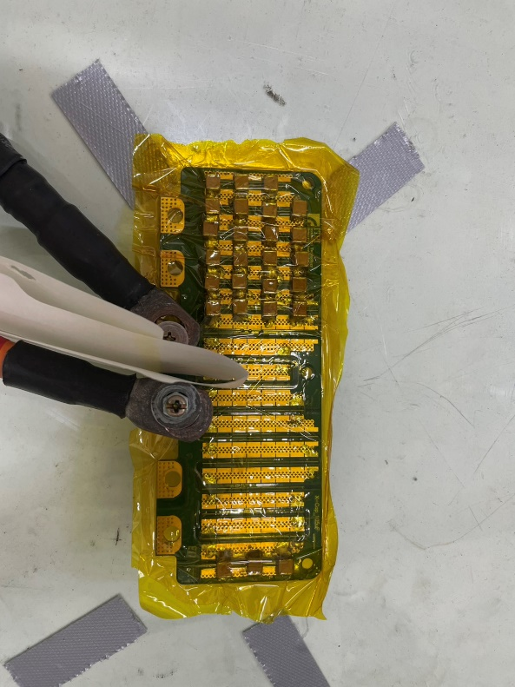

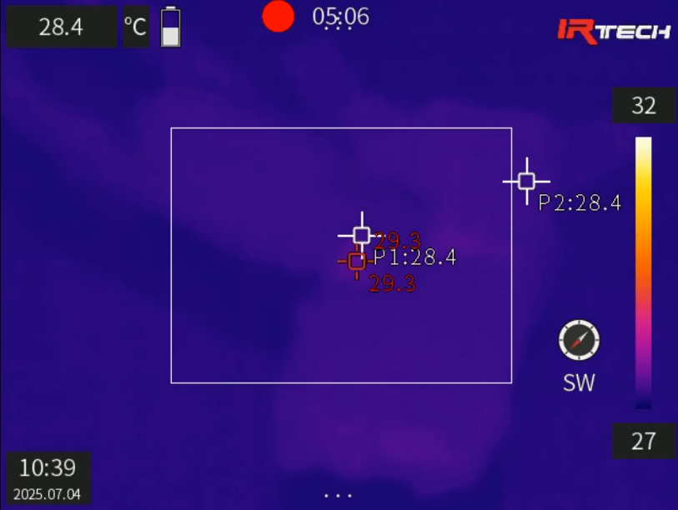

Figure A-6 IR image for last column

Figure A-5 Installation of last column

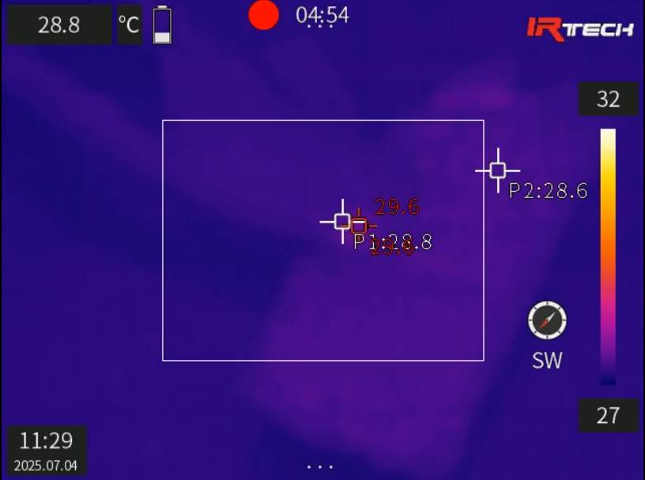
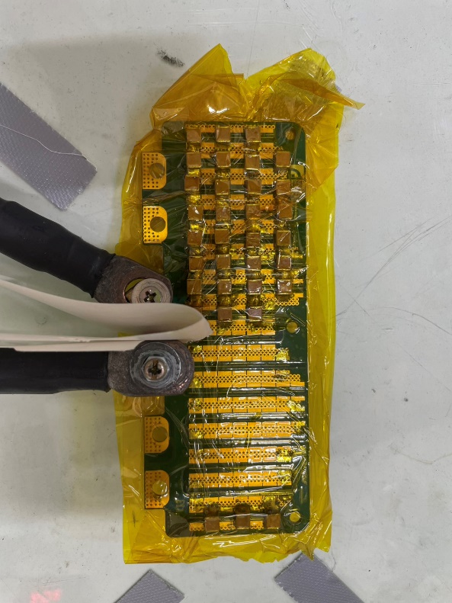
Figure A-8 IR image for column 7 and 8

Figure A-7 Installation of column 7 and 8

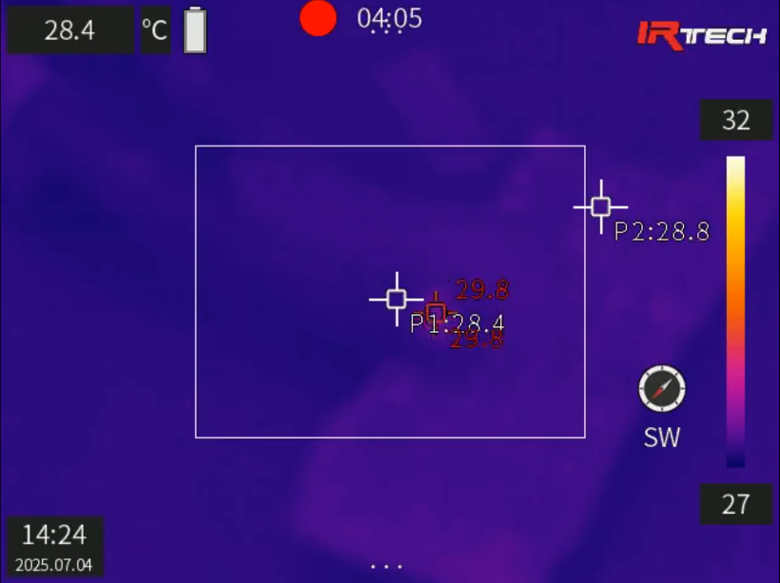
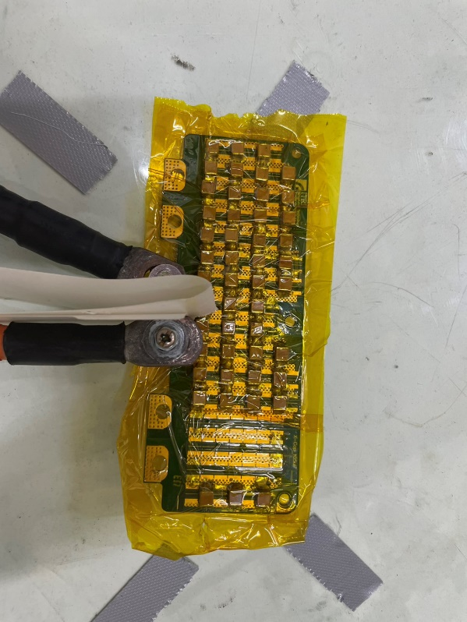
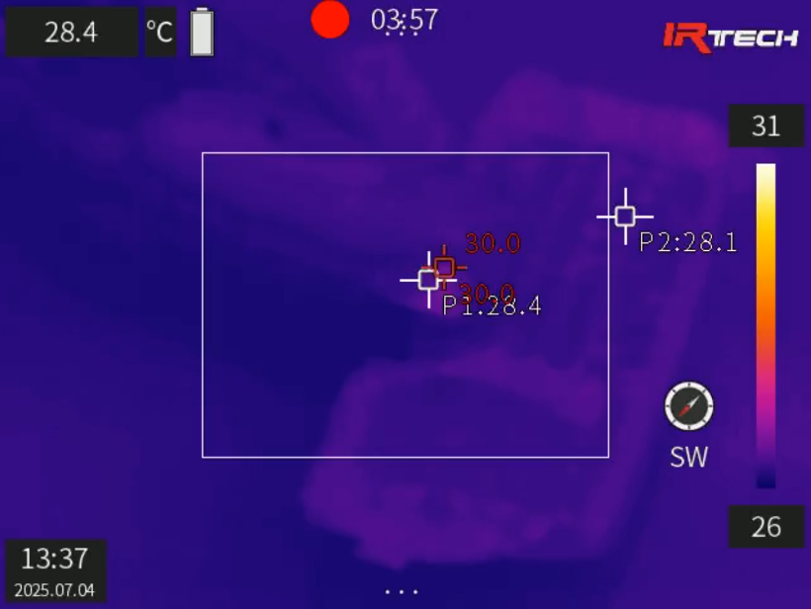
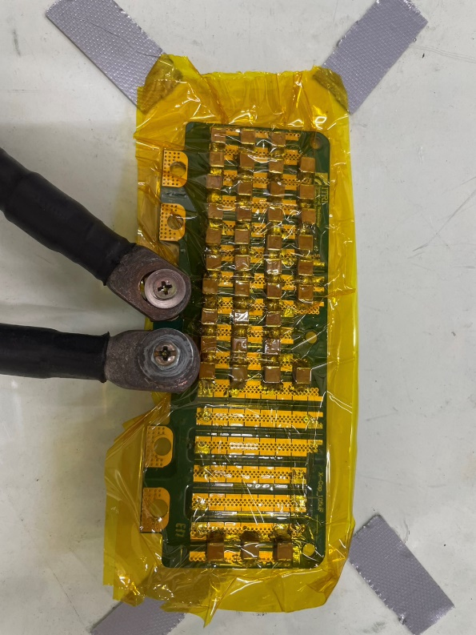
Figure A-12 IR image for column 11 and 12

Figure A-11 Installation of column 11 and 12

Figure A-10 IR image for column 9 and 10

Figure A-9 Installation of column 9 and 10

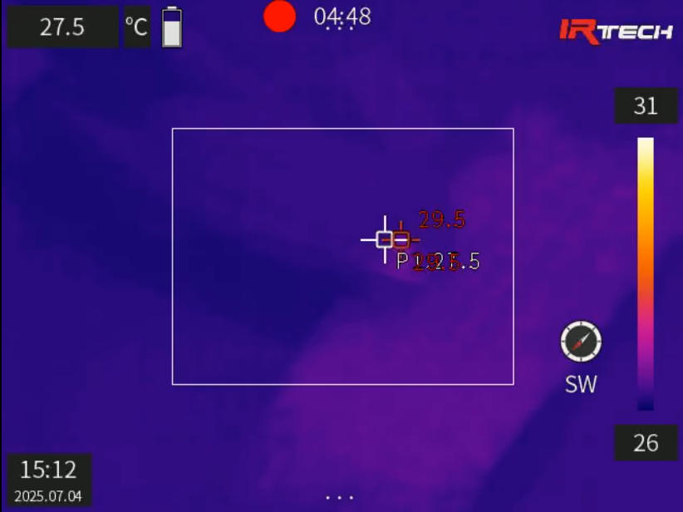
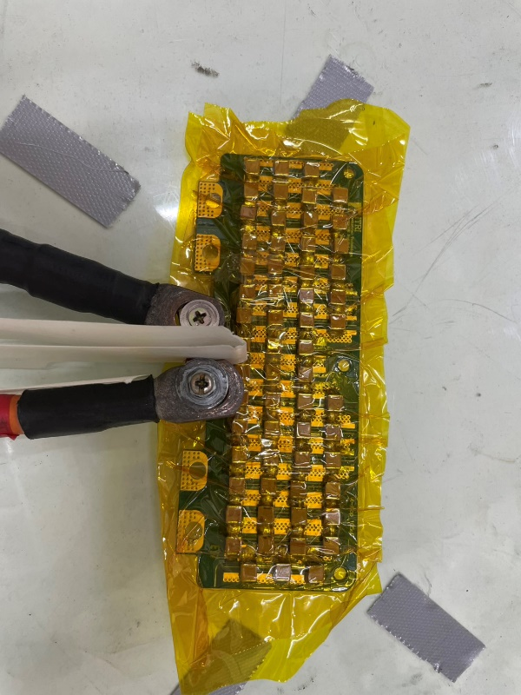
Figure A-14 IR image for column 13 and 14

Figure A-13 Installation of column 13 and 14

7/14/2025 Characterization of LM74800EVM Gate Behavior


Figure A-15 Waveform at 7 V, 0.31A (22.2Ω load)

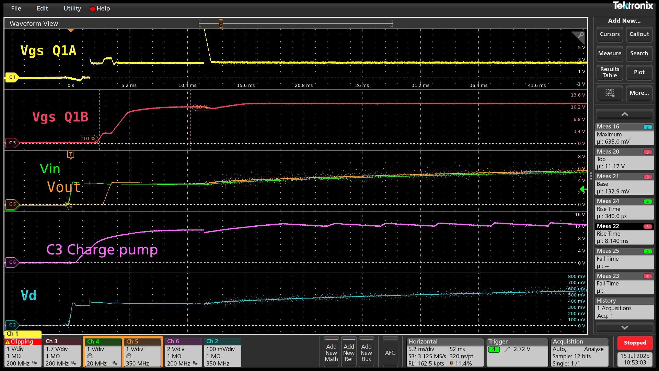
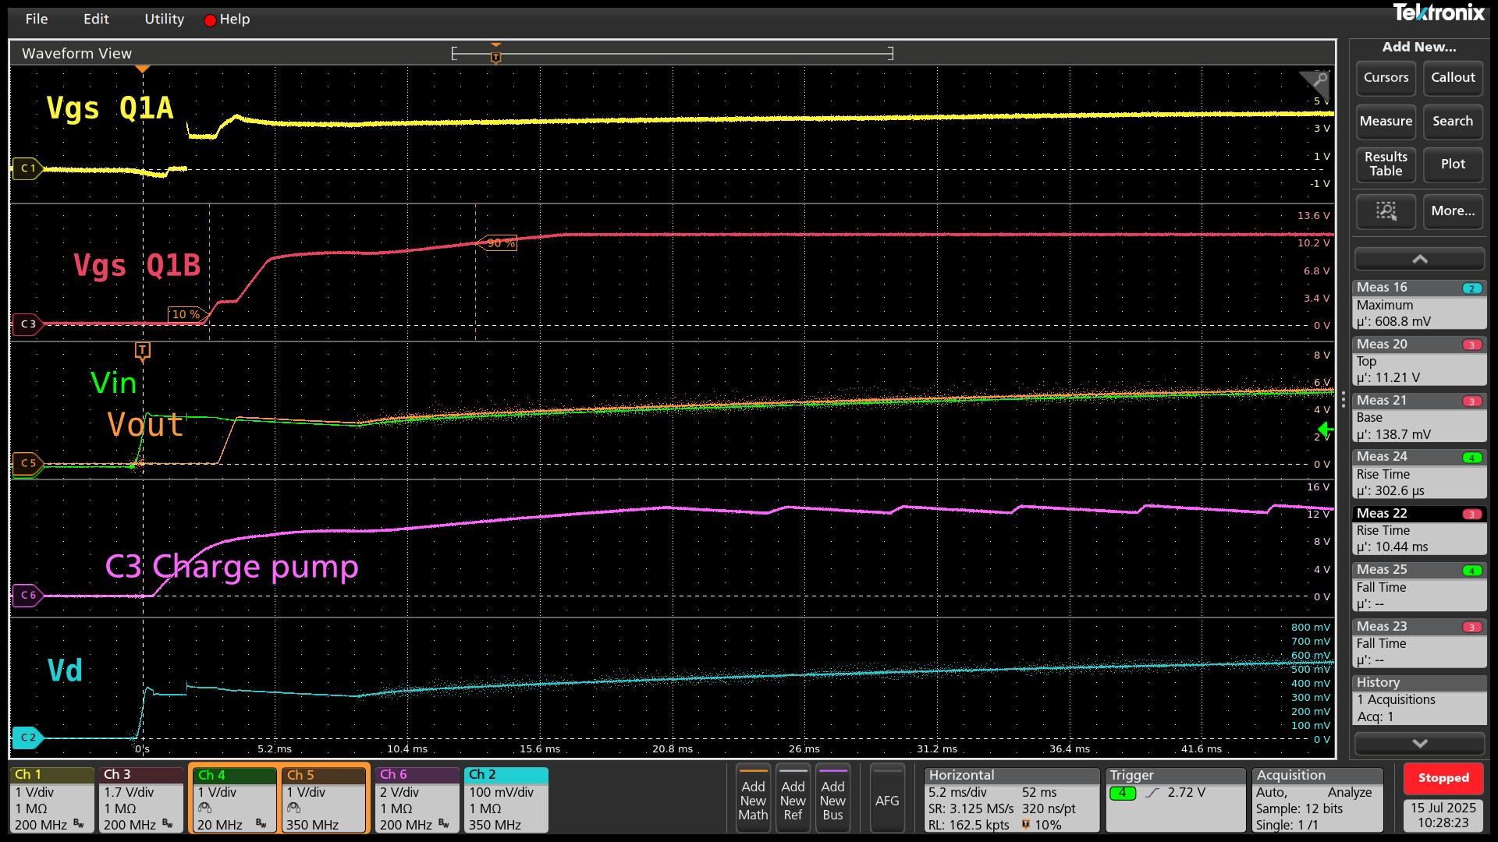
Figure A-17 Waveform at 12 V, 0.02A (885Ω load)

Figure A-16 Waveform at 7 V, 0.57A (12.2Ω load)

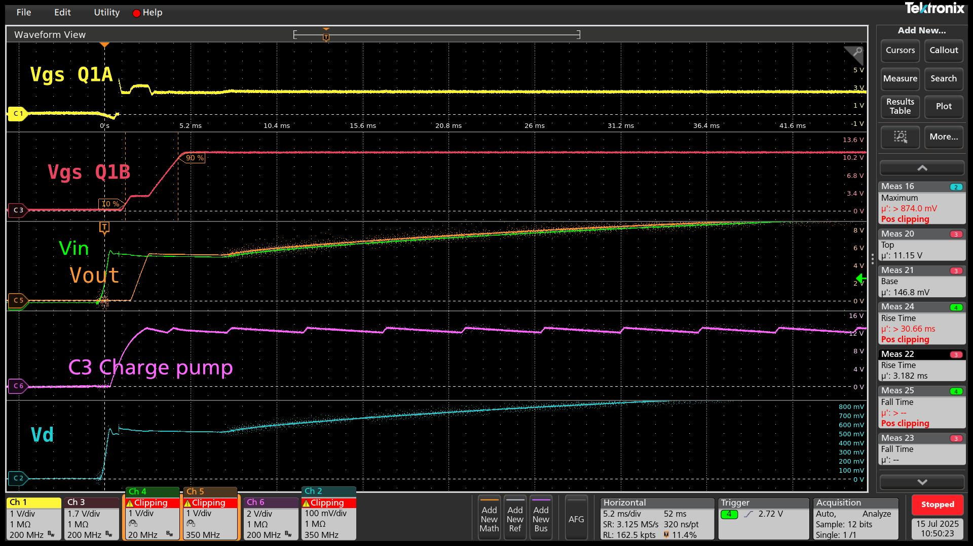
Figure A-18 Waveform at 12 V, 0.02A (910Ω load)

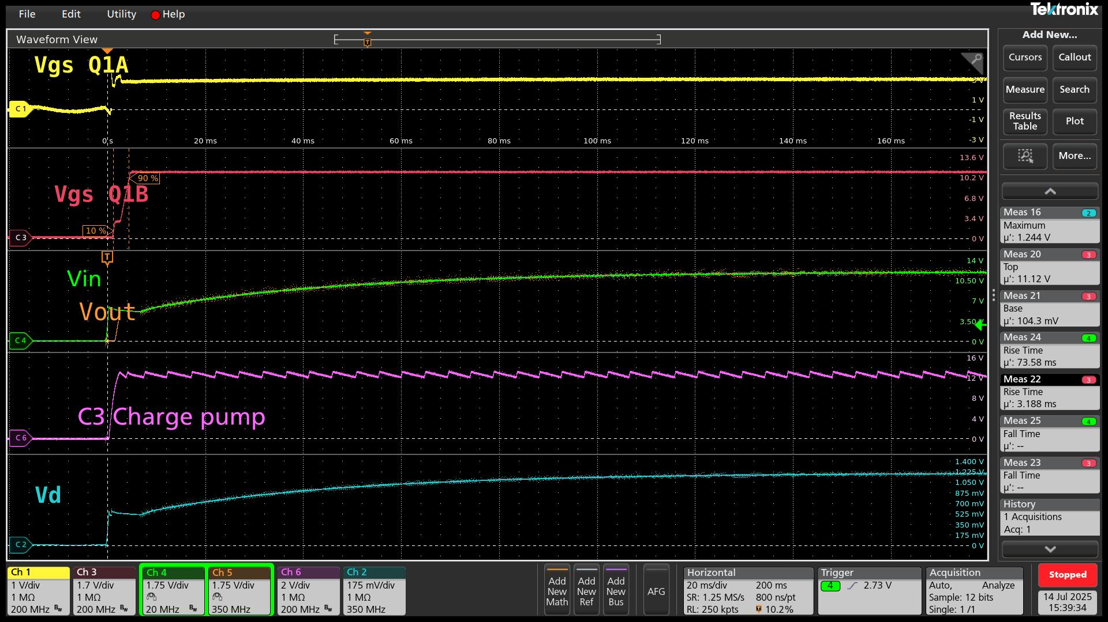
Figure A-19 Waveform at 12 V, 0.25A (50Ω load)

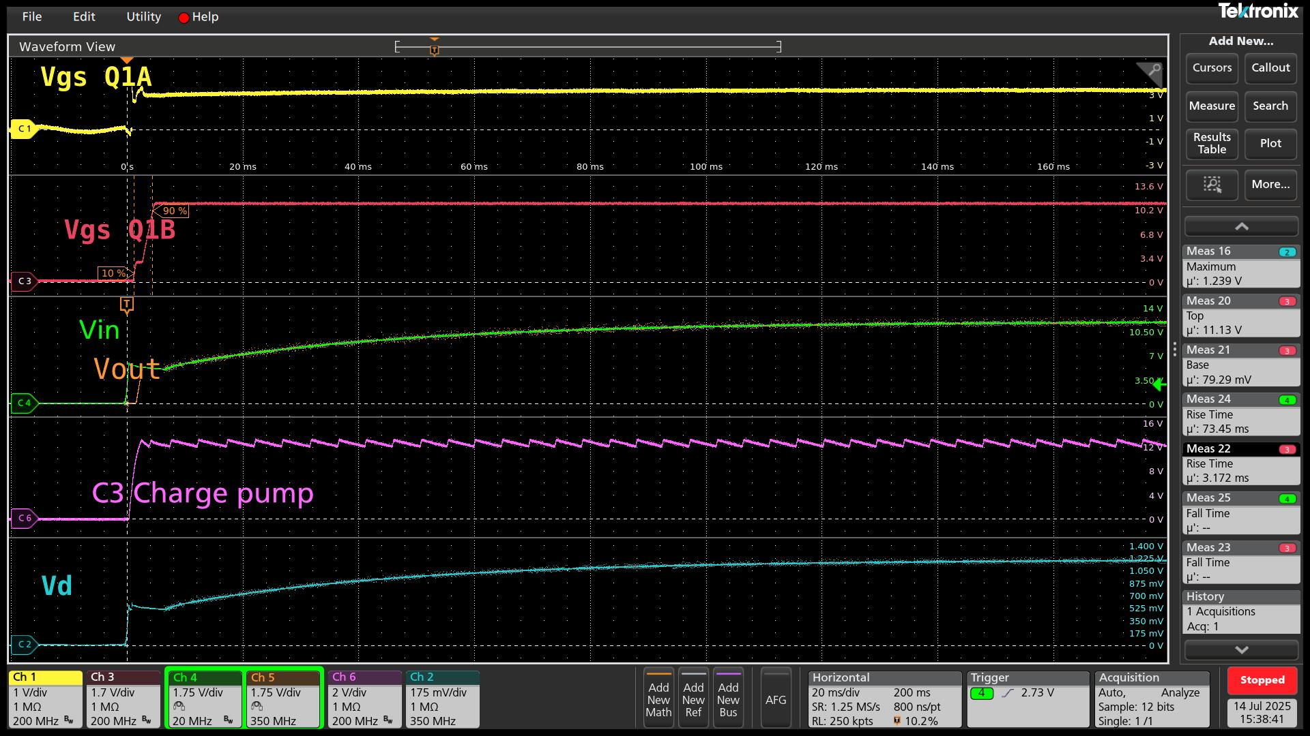
Figure A-20 Waveform at 12 V, 0.37A (32Ω load)

